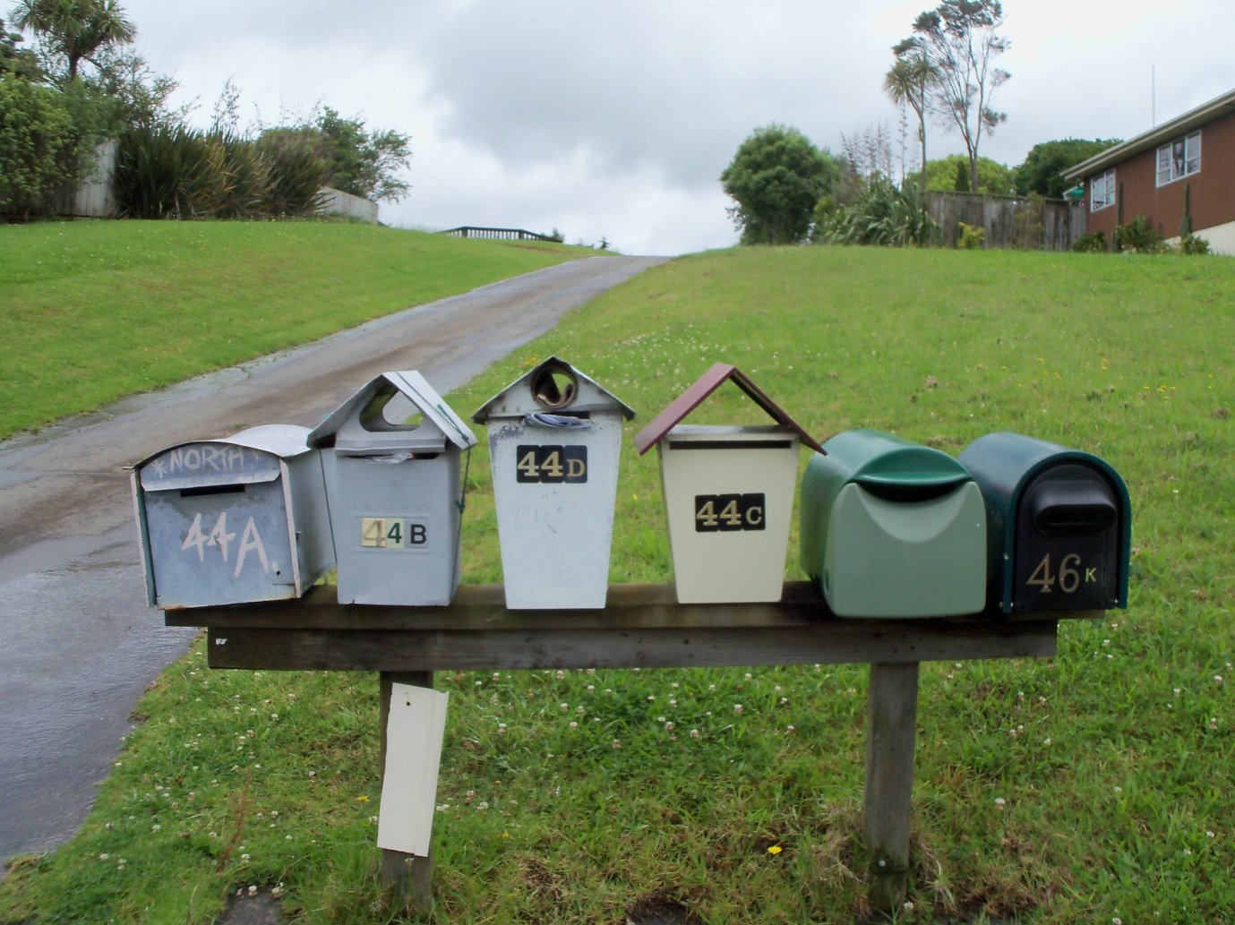
Grant Kings false address – there is no “46K” Garfield Rd, Helensville on any Council records.
King has set this false address up by sticking a “K” onto a bogus letterbox.

