[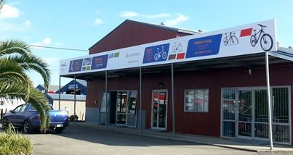](https://www.facebook.com/photo.php?fbid=533178223447305&set=a.533178213447306.1073741831.468065496625245&type=1&relevant_count=1)